|  |
| --- |
| 新东方在线英语学习 |
| 新概念 2 册 |
| Lesson93 |



扫一扫。更多有趣的英语资讯。

# Lesson 93 单词讲解

1.monument ['mɔnjumənt] n.纪念碑

2. statue ['stætʃu:] n.雕像

3.actual ['æktʃuəl] a.实际的，真实的

4. copper ['kɔpə] n.铜

5.support [sə'pɔ:t] v.支持，支撑

6.site [sait] n.场地

7.pedestal ['pedistl] n.底座

8.noble adj. 高尚的，壮丽的 贵族的

a noble soul 高尚的心灵

a noble sight 壮丽的风景

a noble family 贵族的家庭

1. liberty n. 自由

the Statue of Liberty 自由女神像

the liberty of speech 言论自由

1. present v. 赠送 提出 表示 引见

The winner was presented a gold medal.

The committee will present a report next month. He presented his apologies.

May I present Mr. Lee to you?

1. sculptor n. 雕刻家

sculpture n. 雕刻品

1. framework n. 构架，框架 体制，结构

the framework of the tower

the framework of the society 社会结构

1. transport v. 运送

The goods were transported by plane. transportation n. 运输，运送；运输工具

# Lesson 93 课文&语法讲解

1. One of the most famous monuments in the world, the Statue of Liberty, was presented to the United States of America in the nineteenth century by the people of France.

One of the most famous monuments in the world, the Statue of Liberty, was presented to the United States of America in the nineteenth century by the people of France.

被动语态

1. The great statue, which was designed by the sculptor …, took ten years to complete.

非限定性定语从句 L36 77

1. The actual figure was made of copper supported by a metal framework which had been especially constructed by Eiffel.

限定性定语从句

The actual figure was made of copper supported by a metal framework which had been … constructed by Eiffel.

表示被动：

be done done

被动语态 过去分词

谓语动词 非谓语动词表示被动：

The car (call) Bluebird.

I bought a car (call) Bluebird.

1. Before it could be transported to the United States, a site had to be found … and a pedestal had to be built.

主 谓

1. The site chosen was an island at the entrance of … Harbour.
2. By 1884, a statue … had been erected in Paris.
3. By the end of October 1886, the statue had been put together again and it was officially presented to the American people …
4. … the great statue has been a symbol of liberty for the millions people who have passed through New York Harbour to make their homes in America.

has been 现在完成时

symbol of liberty “自由的象征”

# Lesson 93 知识拓展

复习句子：

1. One of the most famous monuments … was presented …

简单句

1. … the statue had been put together … and it was officially presented …

并列句

1. … the great monument has been a symbol … for people who have passed through New

York Harbour …

复合句 （主句+从句）

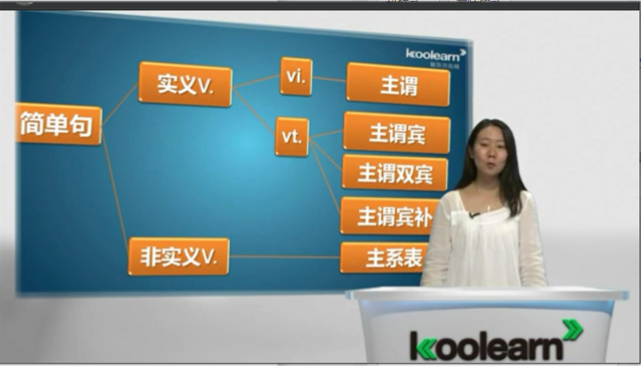

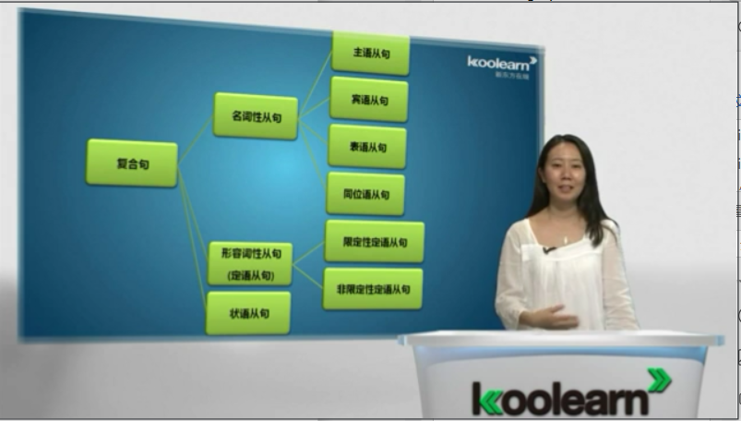

名词性从句 L87

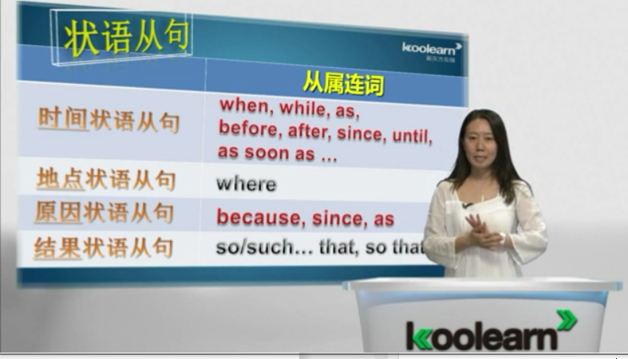

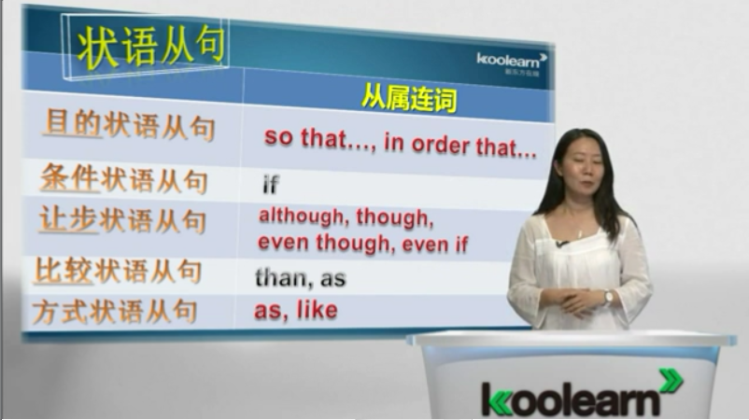

状语从句：完整的句子 前面加一个从属连词 because if while

地点状语从句：stay where you are